2. INTRODUCTION TO ORACLE

- What is Oracle?
- Oracle database server
- Oracle Instance
- What is personal oracle?
- Starting Database
- Starting SQL*Plus
- Summary
- Exercises

What is Oracle?

Oracle is the name of the database management system that comes from Oracle Corporation.

Oracle9i is the latest product released by Oracle Corporation. Unlike Oracle8i, which is only a database management system, Oracle9i is a collection of following software:

- Oracle9i Application Server – Oracle9iAS
- Oracle9i Database Server – Oracle9iDB
- Oracle9i Developer Suite – Oracle9iDS

In simple words Oracle9i is a platform and not a simple database management system.

Oracle9iDB is the database management system that is used to store and access data. Oracle is by far the most widely used relational database management system (RDBMS).

Oracle Corporation is second largest software company next to Microsoft. Oracle Corporation has been targeting Internet programming with the caption - software powers the internet.

This book is about Oracle Database Server. It doesn’t discuss about other products in Oracle9i.

Oracle Corporation is also into Enterprise Resource Planning (ERP). It has Oracle Applications that includes Oracle Financials etc.

Oracle Database Server
Oracle database server is one of the databases that are widely used in client/server computing as back-end. Front-end programs that are written using application development tools such as Visual basic access Oracle and submit SQL commands for execution.

Oracle8i onwards oracle is trying to provide extra facilities that are required to be an internet database.

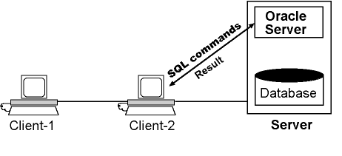

Figure 1: Oracle Server as Server in Client/Server computing model.

Oracle8i provides special features to support various types of data that is to be stored in web sites. Oracle supports both OLTP (online transaction processing) applications as well data warehouse applications, which contain a very large database (VLDB).

One of the biggest advantages of Oracle has been its presence on around 100 different platforms. Oracle is quite scalable, which means it can scale up and down very easily as the requirements change.

Oracle also provides Java Virtual Machine (JVM) as part of database. This enables oracle to run java programs. In fact, starting from Oracle8i, oracle can run programs written either in PL/SQL or Java.

Oracle Instance
Oracle instance is a collection of memory structures and processed that are used to manage oracle database. Each oracle database is to be accessed by one or more Oracle instances. If two or more instances are accessing the same database, it is called as parallel server architecture.

In order to start using an oracle database, we must first start Oracle instance. Oracle instance will them open the database and make it available to users.

It is beyond the scope of this book to discuss what Oracle instance actually contains. Please read “Oracle Concepts” manual for complete information about oracle instance.

In nutshell every oracle installation contains at least one Oracle Instance and one oracle database.

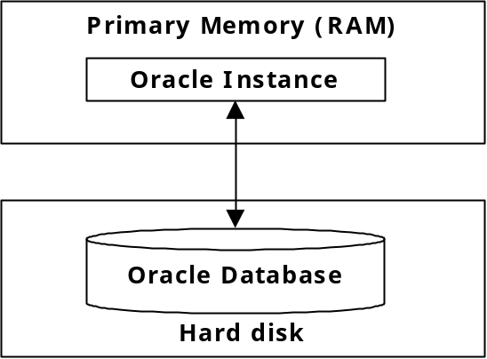

Figure 2: Oracle Instance and Oracle Database.

What Is Personal Oracle?
Personal Oracle is one of the flavors of Oracle. This is not a product that is used by production system (systems where real data is stored). This is more like a learning tool. It runs on desktop PCs. In personal oracle, oracle instance, oracle database and client application all run on the same machine (see figure 3). Whereas in Oracle database server, only oracle instance and database reside on the server and client applications run on clients.

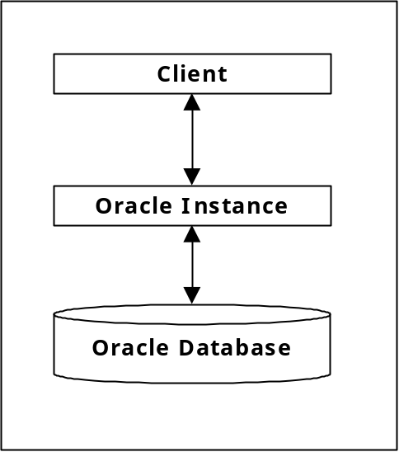

Figure 3: Personal Oracle.

It is also possible to develop an applications using Personal Oracle on you desktop/laptop and deploy them in a client/server environment.

Starting up Database
Before we access oracle database, we must start oracle database. Starting up oracle database means starting oracle instance and associating oracle instance with an oracle database so that oracle instance can access the database.

The process is very length and complicated. Several steps are involved in it. But fortunately we do not have to know all that happens when a database starts. We just need to select an option or two to startup database.

Generally you do not have to startup database in case of Oracle Server running on Windows NT/Windows 2000 as oracle server automatically starts in this case. However, if you ever have to start oracle database on Windows NT/Windows 2000, follow the steps given below:

- Start services program using Administrative Tools -> Service in Windows/2000 or Control Panel -> Service on Windows NT.
- If service OracleServiceOracle8i has not yet started, click on it with right button and select start option from popup menu.
The exact name of the service depends on the name you have given to oracle instance at the time of installing it.

Note: Starting and shutting down the database is the job of Database Administrator. As this books assumes that you are an application developer, it doesn’t get into those details.

Starting up database in Personal Oracle
Unlike Oracle Server in Personal Oracle, Oracle Instance doesn’t start on its own. The Oracle Instance must be explicitly started. The following are the steps to start oracle on Personal Oracle:

- Select start database option in Personal Oracle8i for windows menu.
- When a dialog box is displayed wait until the message Oracle Instance Started appears.
- Click on Close button to close the dialog box.

Starting SQL*PLUS
Sql*plus is a tool that comes along with Oracle. It is used to issue SQL and SQL*PLUS commands. It provides command line interface through which we can enter SQL and SQL*PLUS command.

To start SQL*PLUS, take the steps given below:

- Select start->programs->Oracle - Oracle8i.
Oracle8i is the name of the instance. It may be different on your system.
- Then select Application Development -> SQL Plus.
- When Log On dialog box is displayed, enter username, password and Host string. Use tab key to move from one field to another. For more information about each of these fields, see next section.
- Click on OK.
- If the information supplied is valid then you enter into Oracle and SQL*PLUS will display SQL> prompt.

Username, Password and Host String
Oracle is a multi-user database. Whoever is access the database must log on to database. To log on we have to supply username and password. When the given username and password are recognized by Oracle, it will allow us to access data. A user can access only the data that belongs to his/her and not the data of others. However, it is possible for a user to grant privileges to others so that other can access his/her data.

Creation of users and management of overall security is the responsibility of Database Administrator (DBA). DBA is the person who makes sure that database is functioning smoothly. He is responsible for operations such as taking backup of the database, recovering the database in the event of failure, fine tuning database to get best performance. So, if you want to have a new account under your name, please consult administrator of your database.

Username & Password
Every user who wants to access oracle database must have an account in the database. These accounts are created by DBA. Each account is associated with username and password.

Oracle comes with a set of predefined accounts. The following are the usernames and passwords of these accounts.

Username Password
system manager
sys change_on_install
Scott tiger
Demo demo

Note: when you enter into oracle using either system or sys then you become DBA. That means you get special privileges to perform major operations such as creating users etc.

Host String
Host string is a name that is used to access oracle server that is running on a different machine from client. This is required only when you are trying to access oracle server that is not on the current machine. That means, you never need to use host string for Personal Oracle as client and oracle always run on the same machine in Personal Oracle.

Host string is required when you are trying to connect to Oracle Server running on remote machine. Host string is actually called as net service name. Net service name is a name that is stored in TNSNAMES.ORA file on the client to provide the following information.

Host | Name of the machine or IP address of the machine on which oracle server is running.
Instance name | Name of the Oracle Instance running on the remote machine.
Port Number | Port number of the listener, a program that takes requests from clients. Port number is an integer that uniquely identifies the program on the server.

How to enter SQL statements?
SQL*PLUS allow to types of command to entered at the prompt - SQL and SQL*PLUS.

SQL commands include commands of ANSI/ISO SQL and extra commands added to ANSI SQL by oracle.

The following are the rules to be followed while entering SQL commands.

- An SQL statement may be entered in multiple lines.
- It is not possible to break a word across lines.
- SQL statement must be terminated by semicolon (;).

The following is an example of SQL command. What this command does is not important at this moment.

SQL> select ccode,name
2 from courses
- where fee > 5000;

In the above command, we entered the command in three lines. When you enter semicolon and press enter key then SQL*PLUS will take it as the end of the command. Also note that you have to press enter key at the end of each line.

Note: Both SQL and SQL*PLUS commands are NOT case sensitive.

How to enter SQL*PLUS statements?
SQL*Plus statements are available only in SQL*PLUS. They are not part of standard SQL. SQL*Plus commands are mainly used for two purposes – editing SQL commands and formatting result of query.

The following rules are to be followed while entering these commands.

- The entire command must be entered on a single line.
- No need to terminate command with semicolon (;).
- Commands can be abbreviated. However, the amount of abbreviation is not fixed. Some commands are abbreviated to one letter some are abbreviated to 2 and so on.

The following example show how to use CLEAR SCREEN command of SQL*PLUS.

SQL>clear screen

Or it can be abbreviated to

SQL>cl scr

Common Errors
The following are the common errors that you get while you are trying to log on to Oracle.

Ora-01017: invalid username/password; login denied
The reason for this error is that you have entered a username or password that is not valid. Check whether username you are entering is really existing and password is correctly typed. Sql*plus gives you three chances to type username and password correctly. If you cannot log on successfully in three chances then Sql*plus will exit. However, you can restart Sql*plus again.

ORA-01034: ORACLE not available
The reason for this message is that Oracle Instance is not up and running. You have to first make sure you have started Oracle Instance. Actually there are a few other problems that occurs when Oracle Instance has not started successfully. If this is case in Oracle Server, notify administrator. If this is the case with Personal Oracle, make sure you start database as mentioned in “starting up database” section.

Summary
In this chapter, we have seen what is Oracle and what is the difference between Oracle Server and Personal Oracle. We have seen how to connect to Oracle through SQL*Plus.

In the next chapter, we start creating tables and understanding elementary statements in SQL.

Exercises

- 1. Oracle instance is a collection of _________ and ____________.
- What is the use of HOST STRING___________
- SQL*PLUS commands must be terminated with semicolon (;) [TRUE/FALSE]_________.
- What is the password of user DEM?
- What is difference between user SYS and SCOTT?
- What error message will you get when you try to connect to Oracle but Oracle Instance has not started?

